Global Markets Onboarding System/Portal

Technical Documentation

Version 1.0

Revision History

Date | Version | Description | Author
20-10-2018 | 1.0 | First Draft | Wangudi, Michael Otieno

Table of Contents
1. Introduction 3
1.1 Purpose of this document 3
1.2 Intended Audience 3
1.3 Scope 3
1.4 Definitions and acronyms 4
1.4.2 Acronyms and abbreviations 4
2. General overview 4
2.1 Technologies used 4
2.2 General functioning 4
2.3 Error handling 4
3. Technical requirements 5
3.1 Client requirements 5
3.2 Server Requirements 5
4. System Source structure 5
5. Architecture 6
5.1 High Level Architecture 6
5.2 GLOBAL MARKETS ONBOARDING Class Diagram 7
5.3 User search Sequence Diagram 8
6. References 9

Introduction

Purpose of this document
The purpose of this document is to give technical information about Global Markets Onboarding system design and implementation.

Intended Audience
The intended audiences are:
- Stanbic Bank Kenya IT System support.
- Global Markets Onboarding System Project Manager.
- Future developers to extend or use some ideas of Global Markets Onboarding System.

Scope
This document will describe the design and some technical issues of Global Markets Onboarding System.

Definitions and acronyms

Definitions acronyms and abbreviation

Acronym or  abbreviation | Definitions
GMO | Global Markets Onboarding
POA | Powe Of Attoney
OPS | Operations team
MVC | Model View Controller. Is an architectural pattern that separates an application into three main logical components: the model, the view and the controller. Each of these components are built to handle specific development aspects of an application.
CRUD | In computer programming, create, read, update, and delete (CRUD) are the four basic functions of persistent storage.
EF | Entity Framework is an object-relational mapper (O/RM) that transforms a .NET application database into objects that can be manipulated in the business logic.
CSV | Comma Separated Values – file format that will be used to upload data to the system
OTP | One Time Pin
SQL | Structured Query Language

General overview

Technologies used
Global Markets Onboarding system is a web-based application that is designed to replace the manual signup process of Stanbic Bank Kenya Ltd existing banks clients who want to trade in the banks forex market. We used ASP.NET C#, CSHTML, JavaScript, jQuery on the Frontend and Backend coding which connects to a database designed by MSSQL Server. The system can be access from a standard web browser.

General system functioning
The following are the major system functionalities:
- Register a user/existing client to the system. A user completes her company registration by;
  - Completing the registration process by filing the registration form provided on the home page. The user receives an OTP (which expires after 72Hrs) which is used to complete the registration process upon accepting the terms and conditions for accessing the system and setting a login password
  - Initiation from the admin backend. The banks internal staff (Digital desk team) uploads a list of existing users from a CSV file. The users uploaded receive an OTP (expiry 72Hrs) which the user uses to complete registration. For this option users have to provide their Stanbic Bank Account since they are not uploaded with the upload CSV file
- Provide a step by step process where a logged in client fills and submits an online application form. The client nominates up to 5 signatories and authorized representatives who can trade on the company’s behalf and also accepts the terms and conditions for trading on the forex markets.
- Nominated signatories to complete registration and accept their nominations. They also accept the terms and conditions for trading on the forex markets.
- Nominated authorized representatives to complete registration and accept their nominations. They also accept the terms and conditions for trading on the forex markets.
- Allow internal bank users (Digital Desk, GMO, Sales team, OPS and POA) to get notifications of incoming applications and approve according to their role profiling.
- Allow the system administrators to manage users and reset clients

Technical requirements

Client requirements
As Global markets onboarding system is a web application it could be run on most of custom operating systems via a web browser. We tested the system with Chrome, Firefox and IE and found no problem.

Server Requirements
The following technologies are required for the Global Markets Onboarding server hosting environment.
- MSSQL Server
- IIS 7 or 8
- ASP.NET C# MVC 4

System Source structure
The system uses the standard MVC framework that separates user interaction from business logic. ASP.NET’s EF is incorporated for CRUD operations with raw SQL statements on some data presentation querying.
The main folders that represent the system architecture are;
- Controllers – contains the core business logic and is where most codes are written. The controllers are minified in the bin folder during publishing of the application
- Models and ViewModels – folder that contains database mappings and application logic mainly application and data access logic
- Views – These are user interfaces that displays data

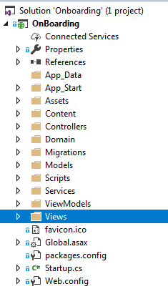

Figure 1: File structure of Global Markets Onboarding System.

Architecture

Architectural design consisted of high-level architecture and detail design including sequence diagrams and class diagrams.

High Level Architecture
The System Design consisted of three tier architecture. It included User Interface Layer (UI), Business Object Layer (BOL) and Data Access Layer (DAL). The user can view the system through the UI. This layer was built using HTML, CSHTML, JavaScript and jQuery.
All other processes are passed on to the BOL for processing. BOL was built using ASP.NET technology C# programming language. It contains business modules and classes that take the appropriate decision and fetch the required information from the client/user through forms submitted and from the underlying database through DAL. The database is built with SQL Server Database. This is depicted in the diagram below.

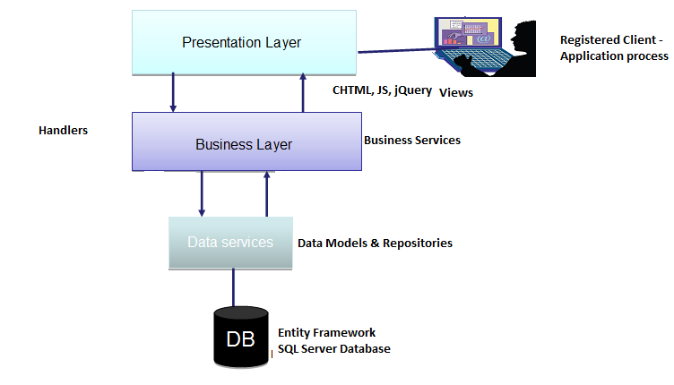
Figure 2: High level architecture

System Class Diagram
The users of the system are: Internal users such as the Administrator, Digital Desk, Poa, Ops, Sales team and GMO. The main external users are Clients, signatories and authorized representatives. Clients are maintained in both users table and registered clients table which contains their details such as accounts, contacts and company details. Clients make applications and nominate other signatories and representatives who also create an account to access and approve their nominations.

The diagram below shows the different table with how they are related to each other.

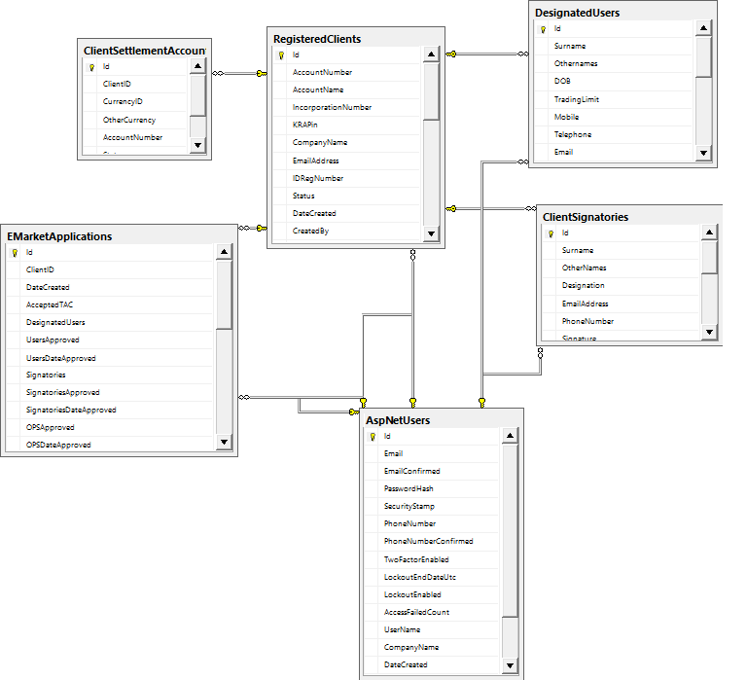
Figure 3: Simplified System Class Diagram

Client Application Sequence Diagram
This sequence diagram is depicting all the interactions between the layers that serve the clients request. The client can register and submit an application

Figure 4: Submit Application Sequence Diagram

